|  |  |
| --- | --- |
| **report-7 Wireless communications**   |  | | --- | | **Prof. Dr. Said E. El-Khamy  Communication & Electronics** | |

|  |
| --- |
| **Asmaa Gamal Abdel-Halem Mabrouk Nagy أسماء جمال عبد الحليم مبروك ناجي 15010473** |
| **4G Systems: (** **LTE ,& Advanced LTE) -**  **Mass MIMO-**  **Tera Hertz Wave Systems**   |

**LTE & Advanced LTE**

LTE (Long-Term Evolution) and Advanced LTE (LTE-A) are both standards for wireless communication, each representing different stages of advancement in mobile network technology. Let's delve deeper into each:

* **LTE (Long-Term Evolution):**

LTE is the next generation of technology which is backward compatible with cellular technologies such as HSPA,GSM,CDMA etc. LTE means Long Term Evolution.LTE which is known as 4G technology is being specified in Release 8 and 9 of the 3GPP standard. Release 10 is referred as LTE-Advanced. The LTE radio transmission and reception specifications are documented in TS 36.101 for the UE ( User Equipment) and TS 36.104 for the eNB (Evolved Node B). Downlink and uplink transmission in LTE are based on the use of multiple access technologies: specifically, orthogonal frequency division multiple access (OFDMA) for the downlink, and single-carrier frequency division multiple access (SC-FDMA) for the uplink. The work on the specifications is ongoing, and many of the technical documents are updated quarterly. The latest versions of the 36-series documents can be found at

* **LTE** is a standard developed by the 3rd Generation Partnership Project (3GPP) to provide high-speed wireless communication for mobile devices.
* **Data Rates:** LTE offers peak download speeds of up to 300 Mbps and peak upload speeds of up to 75 Mbps, though actual speeds can vary based on network conditions.
* **Spectrum Efficiency:** LTE improves spectrum efficiency through advanced modulation techniques like Quadrature Amplitude Modulation (QAM) and Multiple Input Multiple Output (MIMO) technology.
* **Cyclic Prefix:** LTE typically uses a normal cyclic prefix (CP) of around 4.7 microseconds in the time domain.
* **Carrier Aggregation:** While not initially part of the LTE standard, carrier aggregation was introduced as an enhancement later on. It allows multiple LTE carriers to be aggregated, increasing bandwidth and data rates.
* **MIMO:** LTE supports MIMO configurations such as 2x2 MIMO, which improves data throughput and link reliability by using multiple antennas at both the transmitter and receiver.

**LTE-Advanced (LTE-A):**

In 3GPP work on LTE Advanced was started recently. 3GPP release 10 is considered as LTE Advanced after changes in LTE release 9. LTE Advanced shall fulfill 4G requirements as set by ITU.

LTE-Advanced is an evolution of LTE, aiming to further enhance the performance and capabilities of 4G networks. It introduces several advanced features and functionalities to meet the growing demand for high-speed mobile broadband services.

Key features of LTE-A include:

* **Carrier Aggregation:** LTE-A allows multiple LTE carriers (or frequency bands) to be aggregated and utilized simultaneously, increasing overall bandwidth and data rates.
* **Higher Order MIMO:** LTE-A supports advanced MIMO configurations, such as 4x4 MIMO and 8x8 MIMO, enabling even higher data throughput and improved coverage.
* **Enhanced Inter-Cell Interference Coordination (eICIC):** LTE-A employs advanced interference management techniques to mitigate interference between neighboring cells, improving spectral efficiency and overall network performance.
* **Coordinated Multi-Point (CoMP) Transmission:** LTE-A enables coordinated transmission and reception among multiple base stations, enhancing coverage, capacity, and cell edge throughput.
* **Improved QoS Support:** LTE-A enhances QoS mechanisms for better support of diverse services and applications, including multimedia streaming, real-time communication, and IoT (Internet of Things) devices.
* **Peak data rates** of up to 1 Gbps for downlink and 500 Mbps for uplink (depending on the deployment scenario and supported features).

**Difference LTE & advanced LTE:**

|  |  |  |
| --- | --- | --- |
| Specifications | LTE | LTE Advanced |
| Standard | 3GPP Release 9 | 3GPP Release 10 |
| Bandwidth | supports 1.4MHz, 3.0MHz, 5MHz, 10MHz, 15MHz, 20MHz | 70MHz Downlink(DL), 40MHz Uplink(UL) |
| Data rate | 300 Mbps Downlink(DL) 4x4MIMO and 20MHz, 75 Mbps Uplink(UL) | 1Gbps Downlink(DL), 500 Mbps Uplink(UL) |
| Theoretical Throughput | About 100Mbps for single chain(20MHz,100RB,64QAM), 400Mbps for 4x4 MIMO. 25% os this is used for control/signaling(OVERHEAD) | 2 times than LTE |
| Maximum No. of Layers | 2(category-3) and 4(category-4,5) in the downlink, 1 in the uplink | 8 in the downlink, 4 in the uplink |
| Maximum No. of codewords | 2 in the downlink, 1 in the uplink | 2 in the downlink, 2 in the uplink |
| Spectral Efficiency(peak,b/s/Hz) | 16.3 for 4x4 MIMO in the downlink, 4.32 for 64QAM SISO case in the Uplink | 30 for [8x8](https://www.rfwireless-world.com/Terminology/LTE-vs-LTE-Advanced.html) MIMO in the downlink, 15 for 4x4 MIMO in the Uplink |
| PUSCH and PUCCH transmission | Simultaneously not allowed | Simultaneously allowed |
| Modulation schemes supported | QPSK, 16QAM, 64QAM | QPSK, 16QAM, 64QAM |
| Access technique | OFDMA (DL),DFTS-OFDM (UL) | Hybrid OFDMA(DL), SC-FDMA(UL) |
| carrier aggregation | Not supported | Supported |
| Applications | Mobile broadband and VOIP | Mobile broadband and VOIP |

**Generating LTE Waveforms Using MATLAB**

* **LTE waveforms such as RMCs for uplink and downlink**

**LTE Downlink RMC Generator**

* select one of the supported RMCs, such as ‘R.13’ and further configure some of the parameters.

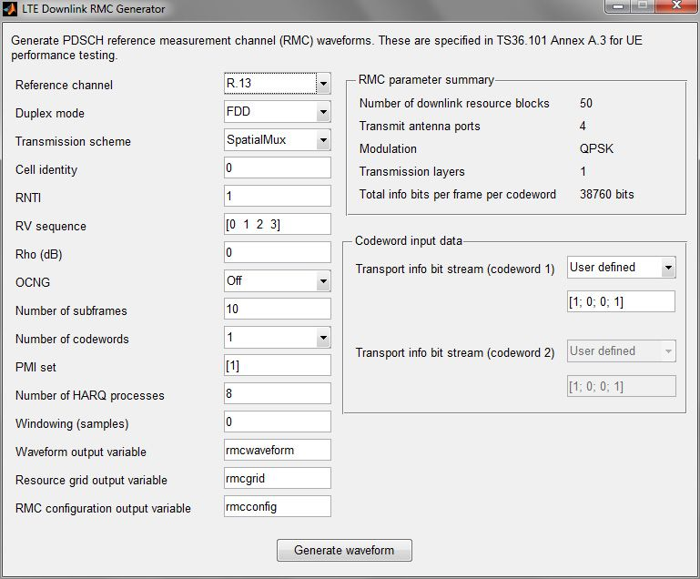

* the real part of subframes 0 through 9 of the R.13 I/Q waveform.
* There are four plots, each corresponding to one of the four transmit antennas for R.13.
* The sixth subframe (subframe 5) includes a hole, consistent with Table A.3.4.2.2-1 [1], which specifies that the sixth subframe should not contain any data physical downlink shared channel (PDSCH) transmission.
* In the sixth subframe, the dark blue plot includes more data because the primary and secondary synchronization signals (PSS/SSS) are located in that subframe and transmitted from only one antenna.

[[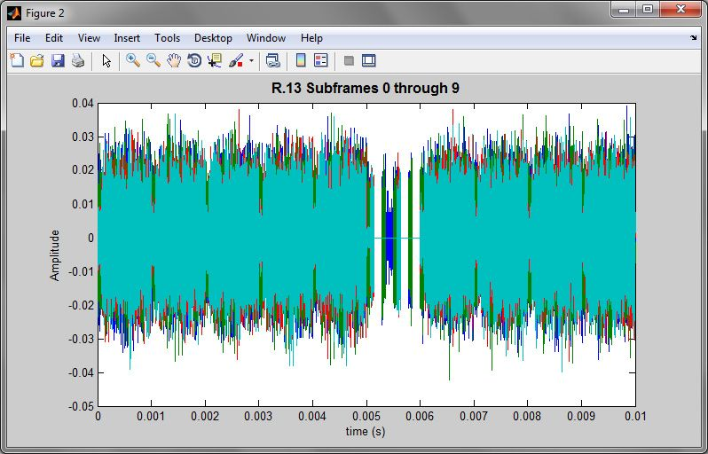](https://www.mathworks.com/company/technical-articles/generating-lte-waveforms.html)](https://www.mathworks.com/company/technical-articles/generating-lte-waveforms.html)

Real part of subframes 0 through 9 of the R.13 I/Q waveform

* shows that the 50 resource blocks allocated for R.13 correspond to a 10 MHz signal bandwidth.

[[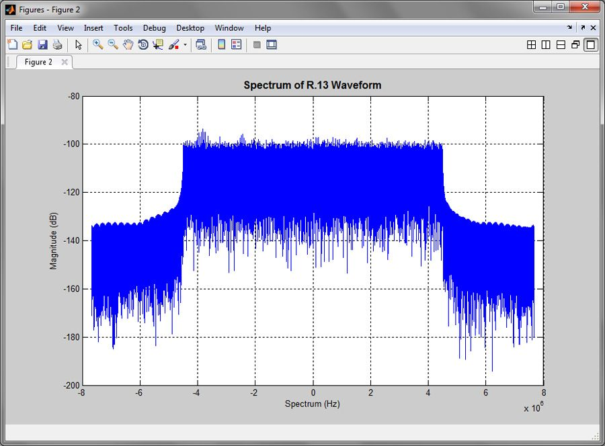](https://www.mathworks.com/company/technical-articles/generating-lte-waveforms.html)](https://www.mathworks.com/company/technical-articles/generating-lte-waveforms.html)

Fifty resource blocks allocated for R.13 correspond to a 10 MHz signal bandwidth.

absolute value of the grid for antenna port 0.

* absolute value of the grid for antenna port 0. A few distinctive features are that:
* No data is allocated in subframe 5 (the sixth subframe) as shown by the low energy.
* Primary and secondary synchronization sequences (PSS/SSS) stand out in the middle of the frequency range in subframes 0 and 5.
* The PDSCH allocation in all subframes but subframe 5 encompasses the whole bandwidth.

[[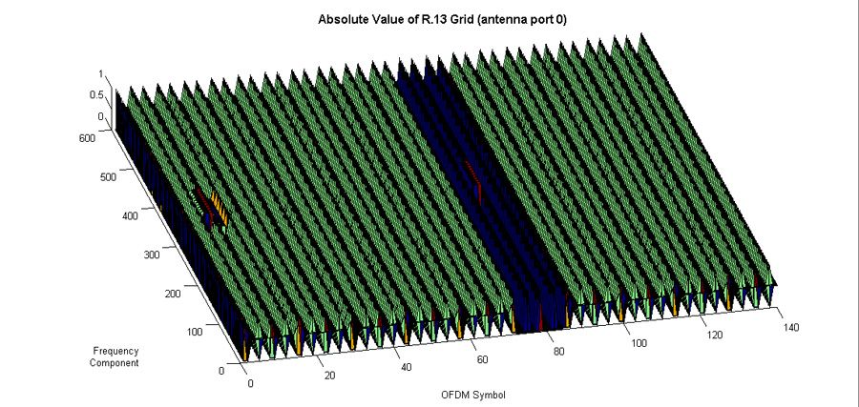](https://www.mathworks.com/company/technical-articles/generating-lte-waveforms.html)](https://www.mathworks.com/company/technical-articles/generating-lte-waveforms.html)

Absolute value of R.13 grid for antenna port 0.

**CODE:**

% Generate the configuration for R.13

rmc = lteRMCDL(‘R.13’);

% Generate a random signal to transmit

Data = randi([0 1], 1, sum(rmc.PDSCH.TrBlkSizes));

% Generate the standard-compliant data

[waveform, txgrid, RMCcfgOut] = lteRMCDLTool(rmc, Data);

**Mass MIMO**

**Definition & Introduction:**

Massive MIMO (massive multiple-input multiple-output) is a type of [wireless communications](https://www.mathworks.com/solutions/wireless-communications.html) technology in which base stations are equipped with a very large number of antenna elements to improve spectral and energy efficiency.

Massive MIMO systems typically have tens, hundreds, or even thousands of antennas in a single [antenna array](https://www.mathworks.com/products/phased-array.html).

Other technologies such as [beamforming](https://www.mathworks.com/discovery/beamforming.html) and spatial multiplexing enable massive MIMO as one of the key technologies for [5G NR systems](https://www.mathworks.com/products/5g.html).

[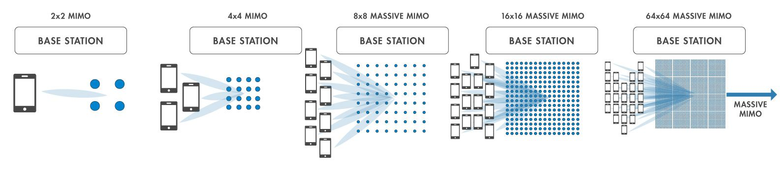](https://www.mathworks.com/discovery/massive-mimo/_jcr_content/mainParsys/image_copy.adapt.full.medium.jpg/1706184141294.jpg)

Benefits of Massive MIMO

* **Improved coverage at cell edge:** In the context of cellular communication, the closer the end user is to the base station, the stronger the signal. As the end user travels further away from the base station, they approach the cell edge where the signal gets weaker. Massive MIMO spatially directs transmissions to focus energy towards the end user, enabling better cell edge performance.
* **Improved throughput:** Using spatial multiplexing with MU-MIMO, wireless communications systems can simultaneously communicate with multiple user equipment (UEs) using the same time-frequency resources. This technology is often used in conjunction with massive MIMO to significantly improve spectral efficiency and aggregate [throughput](https://www.mathworks.com/help/5g/ug/nr-pdsch-throughput.html) for the cell.
* **Enabled by millimeter wave:** Using [millimeter wave](https://www.mathworks.com/help/simrf/ug/modeling-an-rf-mmwave-transmitter-with-hybrid-beamforming.html) frequencies (above 24 GHz), the signal power drops quickly due to path loss. As a result, millimeter wave transmissions enable massive MIMO to boost the signal power. The need for massive MIMO is more apparent in 5G systems where new frequencies in millimeter wave (up to 52 GHz) have been introduced.

[[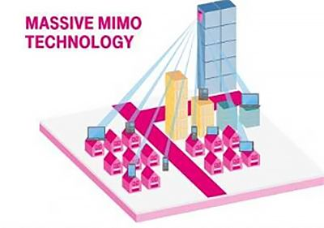](https://www.mathworks.com/discovery/massive-mimo/_jcr_content/mainParsys/image.adapt.full.medium.jpg/1706184141318.jpg)](https://www.mathworks.com/discovery/massive-mimo/_jcr_content/mainParsys/image.adapt.full.medium.jpg/1706184141318.jpg)

**Challenges of Massive MIMO**

* **Modeling, simulation, and testing:** With the introduction of 5G enabling technologies such as massive MIMO and millimeter wave, the challenges of modeling, simulation, and testing are becoming more evident, especially if physical prototypes for radios employing these technologies are not yet available. Configuring these systems may require simulated results rather than results measured in the field.
* **Power consumption:** To achieve the required range needed for 5G millimeter wave transmissions, massive MIMO may require a large number of antenna elements. This demand increases the overall power and cost requirements of a system, although methods such as [hybrid beamforming](https://www.mathworks.com/campaigns/offers/hybrid-beamforming-white-paper.html) can be applied to reduce its power usage.
* **Channel reciprocity:** Massive MIMO is designed for a [time domain duplex](https://www.mathworks.com/help/5g/ug/nr-tdd-symbol-based-scheduling-performance-evaluation.html) (TDD) system, where transmission and reception occurs at the same center frequency. However, TDD requires additional calibration compared to its frequency domain duplex (FDD) counterpart in order to achieve channel reciprocity. This requirement is exacerbated by the deployment of many antennas introduced by massive MIMO.

Software tools such as MATLAB® [wireless communications products](https://www.mathworks.com/solutions/wireless-communications.html) provide tools that help address these challenges.

**Massive MIMO with MATLAB and Simulink**

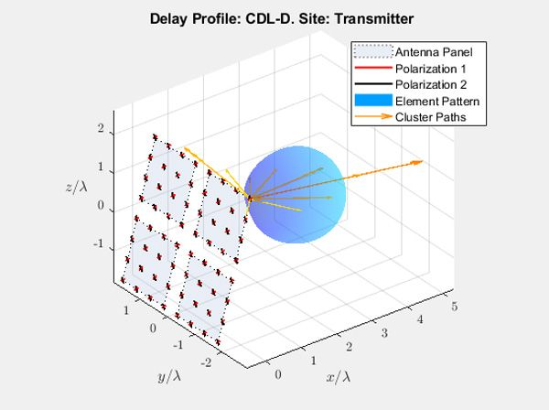

**Tera-Hertz Waves**

**Definition & Introduction:**

Terahertz waves, also known as T-waves or sub-millimeter radiation, are electromagnetic waves with frequencies in the terahertz (THz) range, typically from 0.1 to 10 terahertz. They lie between the microwave and infrared regions of the electromagnetic spectrum.

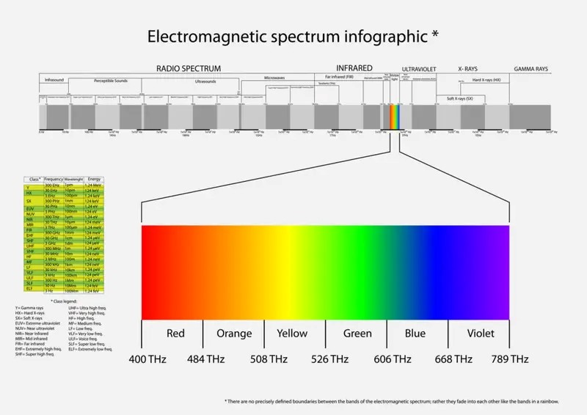

* **Generation:** Terahertz waves can be generated using various techniques, including:

Optical methods: Using lasers to generate terahertz pulses through techniques like photoconductive switches or optical rectification.

* **Electronic methods**: Utilizing electronic devices such as Gunn diodes, resonant tunneling diodes, or quantum cascade lasers.
* **Thermal methods:** Generating terahertz radiation from heated materials, such as hot electron bolometers or quantum well infrared photodetectors.
* **Absorption and Transmission:** Terahertz waves are absorbed by water vapor and certain gases in the Earth's atmosphere, limiting their range for free-space communication. However, terahertz radiation can still penetrate many non-metallic materials, offering potential for imaging and sensing applications.
* **Safety:** Terahertz radiation is generally considered safe for biological tissues because it has insufficient energy to ionize atoms or molecules, unlike X-rays or ultraviolet radiation. However, research is ongoing to understand potential long-term effects of exposure to terahertz waves.

**Challenges:** Despite their promising applications, terahertz technology faces several challenges, including:

* Limited range and atmospheric absorption for free-space communication.
* Development of compact and efficient terahertz sources and detectors.
* Mitigation of noise and interference in terahertz systems.
* Integration of terahertz components into existing technologies.

**Terahertz waves have unique properties that make them useful for various Applications:**

**Imaging:** Terahertz waves can penetrate many materials that are opaque to visible light, such as plastics, ceramics, and clothing. This property makes them valuable for imaging applications, particularly in security screening (e.g., detecting concealed weapons or explosives) and medical imaging (e.g., detecting cancerous tissue).

**Spectroscopy:** Terahertz spectroscopy involves analyzing the interaction between terahertz waves and matter. It's useful for identifying and characterizing materials based on their unique spectral fingerprints. Terahertz spectroscopy has applications in chemistry, biology, pharmaceuticals, and materials science.

**Communications:** Terahertz waves have the potential for high-speed wireless communication systems, offering much larger bandwidths compared to existing technologies like Wi-Fi and cellular networks. However, they face challenges such as limited range and susceptibility to atmospheric absorption.

**Sensing and Detection:** Terahertz waves can detect subtle changes in the properties of materials, making them useful for sensing applications. For example, they can detect defects in materials, monitor environmental conditions, and even analyze the composition of gases.

**Security Screening:** Terahertz waves can penetrate clothing and other materials, allowing for non-invasive security screening at airports, stadiums, and other public venues. They can detect concealed weapons, explosives, and other threats without the need for physical contact.

**Detecting Tera-Hertz Waves**

typically involves specialized equipment and techniques tailored to the specific application. Here's a general overview of how terahertz wave detection can be approached:

**Terahertz Sources:** Before detection, you need a source emitting terahertz radiation. This can be achieved using methods such as optical rectification, photoconductive switches, quantum cascade lasers, or electronic devices like Gunn diodes.

**Terahertz Detectors:**

* **Photoconductive Antennas:** These are commonly used for broadband terahertz detection. They consist of semiconductor materials that generate a photocurrent when illuminated by terahertz radiation.
* **Bolometers:** Terahertz radiation can also be detected using bolometers, which measure changes in electrical resistance caused by the heating effect of the absorbed radiation.
* **Terahertz Field-Effect Transistors (FETs):** FETs can be designed to operate in the terahertz frequency range, allowing for direct detection of terahertz waves.

**Terahertz Imaging Systems:**

* Time-Domain Imaging: This technique involves transmitting short terahertz pulses and measuring the time delay and amplitude of the reflected or transmitted pulses. By scanning the area of interest, a two-dimensional image can be reconstructed.
* Frequency-Domain Imaging: In this approach, the frequency spectrum of the terahertz radiation is analyzed to obtain information about the material properties. This can be useful for spectroscopic imaging.

**Signal Processing:**

* **Data Acquisition:** Terahertz detectors typically produce electrical signals that need to be digitized for further processing.
* **Signal Processing Algorithms**: Various signal processing techniques can be applied to enhance the signal-to-noise ratio, remove artifacts, and extract relevant information from terahertz signals.

Research into terahertz technology is ongoing, with efforts focused on improving device performance, developing new applications, and overcoming technical challenges such as the development of compact and affordable terahertz sources and detectors.

**What Is Parametric Generator In Tera-Hertz Waves?**

A parametric generator in terahertz waves typically refers to a device that generates electromagnetic waves in the terahertz frequency range using a process called parametric amplification or parametric oscillation. In this context, "parametric" refers to the dependence of the device's properties on certain parameters.

In simpler terms, the device utilizes nonlinear optical effects to generate terahertz waves. When an intense pump wave at a different frequency interacts with a nonlinear material, it can create new waves at frequencies that are multiples or sub-multiples of the original frequencies. This process is known as parametric down-conversion or up-conversion, depending on the direction of frequency change.

Parametric generators in the terahertz range have various applications, including spectroscopy, imaging, communication, and sensing, due to the unique properties of terahertz radiation and its ability to penetrate many materials while being non-ionizing.

**(a) Terahertz-wave Parametric Generator (TPG):**

**Principle:**

The TPG operates on the principle of parametric amplification in a nonlinear crystal.

A strong pump beam at a specific frequency (usually a near-infrared laser) interacts with a nonlinear crystal, generating terahertz radiation through a nonlinear optical process.

The terahertz radiation is produced through a process called parametric down-conversion, where the pump photons are converted into signal and idler photons at lower frequencies, satisfying energy and momentum conservation laws.

By controlling the phase-matching condition in the nonlinear crystal, efficient conversion of the pump photons into terahertz radiation can be achieved.

Key Components:

* Nonlinear Crystal: Typically made of materials such as gallium phosphide (GaP) or lithium niobate (LiNbO3), which exhibit strong nonlinear optical properties.
* Pump Laser: Provides the intense pump beam at the desired wavelength to drive the parametric amplification process.
* Optical Components: Lenses, mirrors, and filters are used to manipulate and control the pump and generated terahertz beams.

**Applications:**

* Spectroscopy: TPGs are used in terahertz spectroscopy for studying material properties and molecular vibrations.
* Imaging: They enable terahertz imaging applications for non-destructive testing, security screening, and medical diagnostics.

**(b) Injection-seeded THz Parametric Generator (is-TPG):**

**Principle:**

The is-TPG builds upon the TPG principle but introduces an additional step of seeding the terahertz generation process with a pre-existing terahertz signal.

A seed terahertz signal at the desired frequency is injected into the nonlinear crystal along with the pump beam.

The seed signal helps to initiate and control the parametric amplification process, resulting in more controlled and stable terahertz output.

Key Components:

* In addition to the components of the TPG, the is-TPG requires a terahertz seed source, which can be generated using techniques such as photoconductive antennas or quantum cascade lasers.
* Applications:
* High-resolution spectroscopy: The use of a seeded terahertz source enables precise control over the generated terahertz frequency, leading to high spectral resolution in spectroscopic applications.

**(c) Terahertz Parametric Detection:**

**Principle:**

Terahertz parametric detection involves the reverse process of terahertz generation, where the terahertz radiation is used to modulate an optical signal.

A strong pump beam is combined with the terahertz signal in a nonlinear crystal, leading to the modulation of the optical signal through the process of parametric up-conversion.

The modulated optical signal can then be detected using standard optical detectors, allowing for the extraction of information carried by the terahertz radiation.

* Key Components:
* Nonlinear Crystal: Similar to terahertz generation setups, a nonlinear crystal is used to facilitate the parametric up-conversion process.
* Pump Laser: Provides the intense pump beam required for the modulation of the optical signal.
* Optical Components: Lenses, mirrors, and optical filters are used to manipulate and control the optical signals.

**Applications:**

Terahertz spectroscopy: Parametric detection enables the detection and analysis of terahertz radiation for spectroscopic applications, such as material characterization and gas sensing.

Overall, these techniques leverage the nonlinear optical properties of crystals to generate, control, and detect terahertz radiation, enabling a wide range of applications in science and technology.

